| **Experiment No._01**  **Title:** Exploratory Analysis of IoT Technology |
| --- |

**Batch: B–1 Roll No.: 16010422234 Experiment No.: 01**

**Aim:** Exploratory Analysis of IoT Technology

**Resources needed:** Internet.

**Theory:**

**Pre Lab/ Prior Concepts:**

IoT (Internet of Things) is an advanced automation and analytics system which exploits networking, sensing, big data, and artificial intelligence technology to deliver complete systems for a product or service. These systems allow greater transparency, control, and performance when applied to any industry or system.

IoT systems have applications across industries through their unique flexibility and ability to be suitable in any environment. They enhance data collection, automation, operations, and much more through smart devices and powerful enabling technology.

Augmented reality

Ambient intelligence

Calm technology

Computer accessibility

Context-aware-pervasive systems

Human-centered computing

Human-computer interaction

Mobile interaction

Natural user interface

Pervasive game

Pervasive informatics

Physical computing

Radio-frequency identification

Sensor grid

Smart, connected products

Sentient computing

Smart device

System on chip

Task computing

Trans reality gaming

Ubiquitous commerce

Ubiquitous learning

Ubiquitous robot

User experience

Virtual reality

Wearable computer

Ambient media

Internet of Every Things

**Activity:**

**1. For this experiment students have to decide the unique IoT device / service / application for study and need to explore, on the basis of Architecture, Technologies, Protocols and Methodology.**

**2. Analyze IoT devices from Architecture, Technologies, Protocols and Methodology point of view and give description for the same.**

**Results: (Program printout with output / Document printout as per the format)**

For this experiment, the focus will be on **"IoT-Enabled Real-Time Traffic Monitoring and Control Management for Intelligent Transportation Systems (ITS)"**. This system can provide real-time data on traffic conditions, vehicle counts, congestion, and accidents. It uses a variety of sensors, cameras, and data analytics to optimize traffic flow, reduce congestion, and improve safety.

**Architecture:**

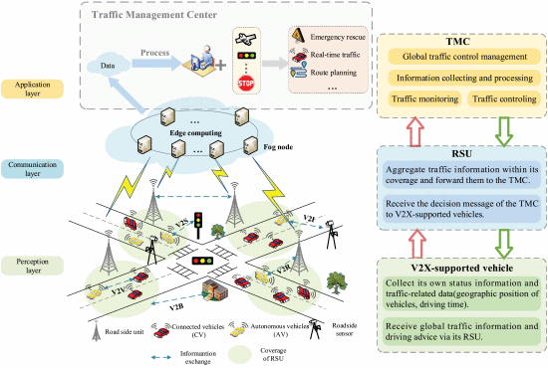

The architecture of an IoT-enabled real-time traffic monitoring and control system generally follows a layered model. Here's an overview of the key layers:

1) Perception Layer (Sensors & Actuators):

This is the physical layer where data is collected using sensors such as cameras, infrared sensors, GPS, and vehicle count sensors. This layer also includes actuators that can control traffic signals based on real-time data.

2) Network Layer (Communication Infrastructure):

The collected data from sensors is transmitted through communication networks to a centralized system. IoT systems typically rely on various networking technologies such as Wi-Fi, 4G/5G, LPWAN (Low Power Wide Area Network), or even satellite communication for real-time data transfer.

3) Edge/Processing Layer:

This layer processes the raw data at the edge (near the source) to filter, analyze, and make immediate decisions. This is where edge computing comes into play, enabling fast data processing to reduce latency. For example, if a traffic congestion threshold is exceeded, traffic signals can be automatically adjusted without needing to send data to the cloud.

4) Application Layer:

This layer includes the real-time traffic control system and any user-facing applications, such as traffic management dashboards for city officials or drivers receiving real-time alerts on traffic conditions. It is also where AI algorithms for traffic prediction and control are implemented.

**Technologies**:

The following technologies are typically used in IoT-enabled traffic management systems:

1) Sensors and Data Collection:

IoT-enabled devices such as cameras, radar, ultrasonic sensors, and environmental sensors gather traffic-related data, including vehicle counts, speeds, and road conditions.

2) Data Analytics and Machine Learning:

The data collected is processed and analyzed using machine learning algorithms to predict traffic patterns, detect anomalies, and optimize signal timings in real-time.

3) Cloud Computing:

Large-scale data processing, storage, and advanced analytics may occur in the cloud. This allows for long-term data analysis and traffic prediction models, helping city planners optimize transportation infrastructure.

4) Edge Computing:

Data is processed at the edge to enable quick decision-making, especially in real-time applications like controlling traffic lights based on live data, reducing latency and network load.

**Protocols:**

Several IoT communication protocols ensure secure, reliable, and efficient data exchange between devices in the traffic monitoring system. Key protocols include:

1) MQTT (Message Queuing Telemetry Transport):

MQTT is a lightweight messaging protocol commonly used in IoT systems. It is ideal for real-time communication and is designed for low-bandwidth, high-latency networks, making it well-suited for traffic monitoring applications.

2) CoAP (Constrained Application Protocol):

CoAP is a protocol designed for IoT devices with limited resources. It operates over UDP (User Datagram Protocol) and is used for device-to-device communication in low-power environments.

3) HTTP/HTTPS:

Standard web protocols like HTTP and HTTPS may be used for communication between IoT devices and the cloud-based traffic management system, especially for sending periodic data or alerts.

4) Zigbee / LoRaWAN / 5G:

Depending on the scale of the IoT network, wireless communication standards such as Zigbee or LoRaWAN (for long-range, low-power networks) may be used for IoT devices. Additionally, 5G provides high-speed connectivity for real-time traffic monitoring.

**Methodology:**

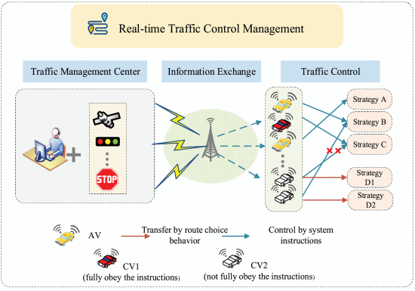

The methodology of deploying an IoT-enabled real-time traffic management system involves the following steps:

1) System Design:

Define the goals (e.g., traffic flow optimization, congestion control) and design the system architecture, including sensor placement, network connectivity, and cloud infrastructure.

2) Sensor Deployment:

Install sensors at strategic locations such as traffic intersections, highways, and pedestrian crossings. Sensors can detect vehicle counts, traffic speed, and environmental conditions.

3) Data Collection and Transmission:

Sensors collect data and transmit it through appropriate communication protocols (e.g., MQTT, CoAP) to the processing layer or cloud server for further analysis.

4) Data Processing and Analysis:

The data is analyzed using machine learning algorithms, edge computing, and cloud-based analytics to generate actionable insights, such as detecting traffic congestion or predicting peak traffic hours.

5) Real-Time Control:

The system uses the analysis to automatically adjust traffic signals, provide real-time updates to drivers, and optimize routes, improving overall traffic flow.

6) User Interface:

A user interface (dashboard) allows traffic operators or municipal authorities to monitor traffic conditions, receive alerts, and control the system manually if needed.

The output of the IoT-enabled traffic management system could include:

**.** Real-time traffic flow data.

**.** Automatic adjustments to traffic signals.

**.** Alerts for accidents or congestion.

**.** Predictions for future traffic conditions.

**Questions:**

**1) How IoT is important in the advanced computing era?**

**Ans:** IoT is crucial in the advanced computing era as it connects devices, enabling real-time data collection and automation. It enhances decision-making through big data and AI, supports smart systems, and drives innovations in industries like healthcare, manufacturing, and energy. IoT also enables edge computing, reduces latency, and improves scalability in computing resources. Additionally, it fosters sustainability by optimizing resource usage and enhances user experiences with personalized services. Overall, IoT is key to realizing the potential of advanced technologies like AI, cloud computing, and cybersecurity.

**Outcomes: CO1 – Understand journey of IoT from M2M communication and its perceived**

**applications**

**Conclusion:**

IoT plays a pivotal role in the development of intelligent transportation systems by enabling real-time monitoring and management of traffic conditions. Through the use of advanced sensors, data analytics, and communication protocols, IoT enhances traffic flow, reduces congestion, and improves road safety. The integration of IoT with edge and cloud computing allows for efficient decision-making and operational efficiency in transportation systems.

**Grade: AA / AB / BB / BC / CC / CD /DD**

**Signature of faculty in-charge with date**

**Books:**

1. Jan Holler, Vlasios Tsiatsis, Catherine Mulligan, Stefan Avesand, Stamatis Karnouskos, David Boyle, “From Machine-to-Machine to the Internet of Things: Introduction to a New Age of Intelligence”, 1st Edition, Academic Press, 2014.

2. Vijay Madisetti and Arshdeep Bahga, “Internet of Things (A Hands-on-Approach)”, 1stEdition, VPT, 2014.

3. Dr. Ovidiu Vermesan, Dr. Peter Friess, “Internet of Things - From Research and Innovation to Market Deployment”, River Publisher, 2014